**Engineering**

**Passport**

**to**

**Success**

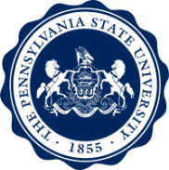

**2018/2019**

Name

Email address

This *Passport to Success* has been developed to help you achieve your academic and professional goals while learning more about what it means to be a Penn State student. A committee of students and faculty created this concept as part of the College’s plan for First-Year Engagement. We expect that through these activities you will connect with the Penn State community, become informed about opportunities, and learn how to avail yourself of the resources at Penn State. We wish you all the best as you embark on this exciting and worthwhile journey to becoming a *World-Class Engineer*.



Andy Lau, First-Year Seminar Coordinator

How to complete this Passport:

1. In each of the five objective areas, choose one of the activities to participate in and do it. For more information on the activities listed in the *Passport*, go to <http://www.sedtapp.psu.edu/first-year-engagement/index.aspx>.
2. If appropriate, provide evidence that you have attended. Describe the evidence in the text box, e.g., photo at event, and paste in images of evidence at the end of the passport.
3. Complete the reflection section by thoughtfully writing several sentences about what you got out of the activity, and responding to the questions in each area.
4. Submit the Passport to your FYS faculty as requested.

You are responsible for completing the Passport as part of your First-Year Seminar.

***The Path to Becoming a World-Class Engineer***

begins with undergraduate study and requires a commitment to lifelong learning and professional development.

World-Class Engineers are:

**Solidly Grounded**

World-Class Engineers are solidly grounded in fundamentals of their discipline and are committed to lifelong learning.

**Technically Broad**

World-Class Engineers are conversant in multiple technical disciplines. They design solutions that span business functions such as finance, marketing, legal and manufacturing.

**Globally Engaged**

World-Class Engineers understand the worldwide nature of their profession and are sensitive to the speed required to keep pace in geographically and culturally diverse environments.

**Ethical**

World-Class Engineers uphold the highest ethical standards. They readily identify, and carefully address, ethical issues that arise in their professional lives.

**Innovative**

World-Class Engineers develop precise definitions of complex problems and formulate sustainable solutions by thinking creatively across technical, business, social and environmental dimensions.

**Excellent Collaborators**

World-Class Engineers seek optimal outcomes through collaboration and honor intellectual property rights of all partners. They work effectively within co-located and geographically dispersed teams.

**Visionary Leaders**

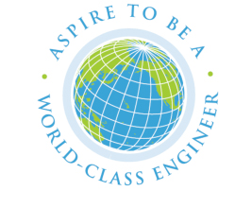World-Class Engineers are courageous, customer-oriented leaders who develop visions that deliver successful results.

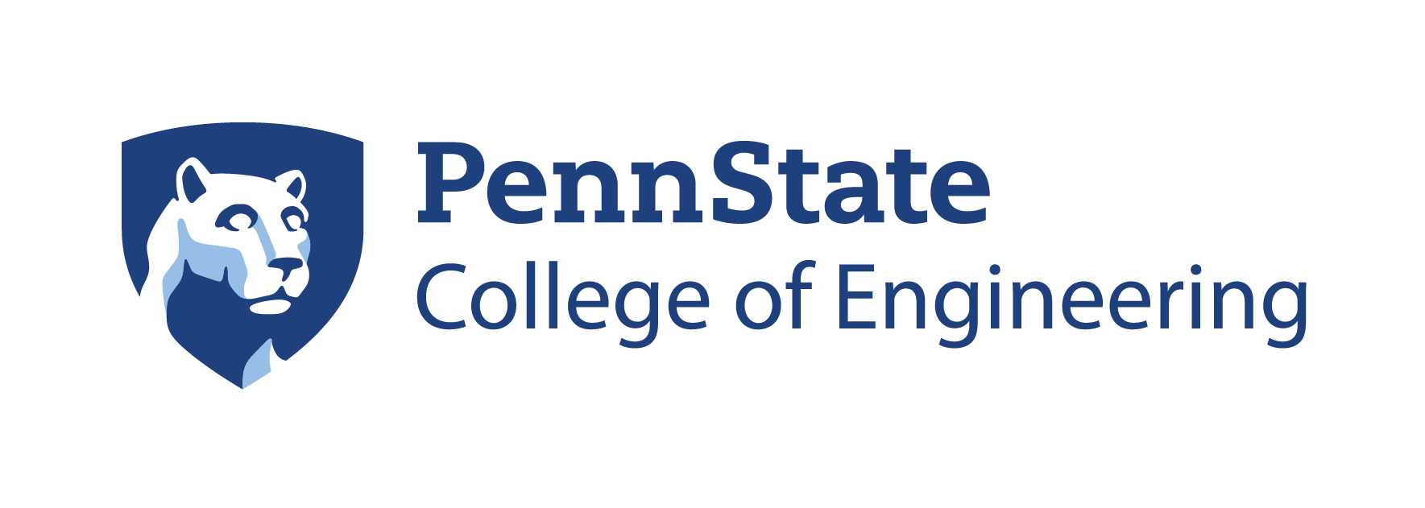

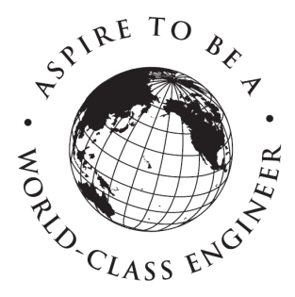 *www.engr.psu.edu*

**Objective 1: University study**

Activities (choose one and underline it):

* 1. Attend a public speech or presentation
  2. Attend a campus cultural event (play, Broadway show, symphony, etc.)
  3. Volunteer at a service event
  4. Other as approved by FYS faculty

Date attended:

Specific name of event:

Evidence of participation:

Reflection – Describe how this University event has enriched your educational experience?

**Objective 2: Academic Community**

Activities (choose one and underline it):

1. Attend a Major Night (fall only)
2. Attend the Career Fair (fall) or Engineering Career Fair (spring)
3. Attend an engineering student organization meeting
4. Other as approved by FYS faculty

Date attended:

Specific name of event:

Evidence of participation:

Reflection – What have you learned about majors or minors, or the careers they prepare you to pursue?

**Objective 3: Tools & Resources**

Activities (choose one and underline it):

1. Meet with an international engineering student envoy
2. Meet with an engineering career student envoy
3. Tour a Library, Learning Factory, or Career Services
4. Other as approved by FYS faculty

Date attended:

Specific name of event:

Evidence of participation:

Reflection – What have you learned about the resources available to you to assist you in meeting your academic or professional goals?

**Objective 4: Relationships**

Activities (choose one and underline it):

1. Participate in the Engineering Orientation Network (EON)
2. Meet with an academic advisor to discuss your progress or an academic goal
3. Attend a university (not engineering) student organization meeting
4. Other as approved by FYS faculty

Date attended:

Specific name of event:

Evidence of participation:

Reflection– What have you learned about relationships and your ability to form personal, academic and professional connections?

**Objective 5: Responsibilities**

Activities (choose one and underline it):

1. Participate in one of the World in Conversation discussions (your faculty member will initiate and you will be contacted by email to schedule a specific time)
2. Other as approved by FYS faculty

Date attended:

Specific name of event:

Evidence of participation:

Reflection– What have you learned about your roles and responsibilities in creating and contributing to civil community with high integrity?

Evidence – paste in any images of evidence and refer to them in the section they relate to.